Compose and Create: Despite the differences in our histories, culture, language, government style, etc, human beings are more alike than they are different. Placed in similar circumstances, there are common behaviours and shared values among us.
Look through the Photographs of the Year images on the following website (QR Code) and choose any 5 to study.
1. Write out the name of the image (You can submit this in a text version – through
Word doc, Google Docs, or Notability PDF, etc. and attach the photo with your responses.)
2. Give a brief description of what you see/notice depicted in the image choice
3. Explain whether you see admirable values or qualities of the people in the image or a darker side of humanity. Explain your answer with reference to specifics in the image. Option: If you can recognize both positive and negative qualities of human beings, you can explore that.
4. Identify one thing you can say you have in common with the person(s) in the image selection.
5. You can check the Homework Blog Page for an example of this activity.

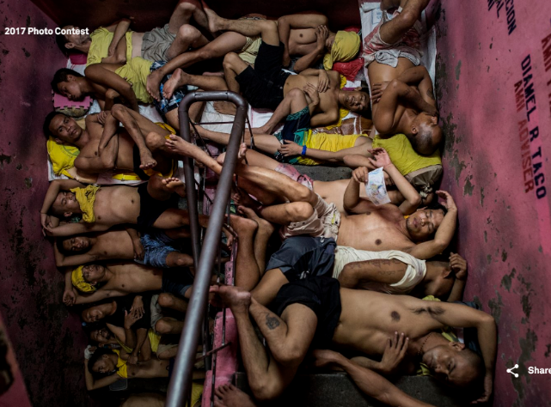
Name of Image & Photographer’s Name: The Philippines’ Most Crowded Jail by Noel Celis
can include link to image:
https://www.worldpressphoto.org/collection/photo/2017/28793/1/2017-Noel-Celis-GN3
Description of what you see/notice within the image (details):
- Extremely cramped living conditions for men in a prison
- They’re laying one (almost) on top of each other, tightly laid side by side
- They’re organized tightly sleeping on the steps of the stairwell, which isn’t wide enough for them to stretch their legs out (must be incredibly uncomfortable to lay on and for body position as well)
- If they’re sleeping here, it must be the best location for them, which speaks to how cramped the rest of the sleeping quarters must be.
- Dehumanizing to live like this, despite being convicted criminals
Admirable or Dark Qualities You Recognize in the Image:  - Dark- retribution – punishing offenders without mercy  - Dark – likely loss of hope | - Allowing people to live in conditions like this shows the decisions makers have no feelings for them as human beings  - Living in such conditions, how could someone maintain a sense of humanity or hope?
What you share in common with anyone in this image:
If I had been born into similar conditions, in a country that was overcrowded without resources for people or job opportunities, I likely would have turned to crime or drugs and found myself in the same place as these few. None of them would have set out determined to end up in prison like this. Good people in bad situation do bad things. (Stanford Prison Experiment proof)

1. Name of Image & Photographer’s Name:
can include link to image:
Description of what you see/notice within the image (details):

Admirable or Dark Qualities You Recognize in the Image:

What you share in common with anyone in this image:

2. Name of Image & Photographer’s Name:
can include link to image:
Description of what you see/notice within the image (details):

Admirable or Dark Qualities You Recognize in the Image:

What you share in common with anyone in this image:

3. Name of Image & Photographer’s Name:
can include link to image:
Description of what you see/notice within the image (details):

Admirable or Dark Qualities You Recognize in the Image:

What you share in common with anyone in this image:

4. Name of Image & Photographer’s Name:
can include link to image:
Description of what you see/notice within the image (details):

Admirable or Dark Qualities You Recognize in the Image:

What you share in common with anyone in this image:

5. Name of Image & Photographer’s Name:
can include link to image:
Description of what you see/notice within the image (details):

Admirable or Dark Qualities You Recognize in the Image:

What you share in common with anyone in this image:

