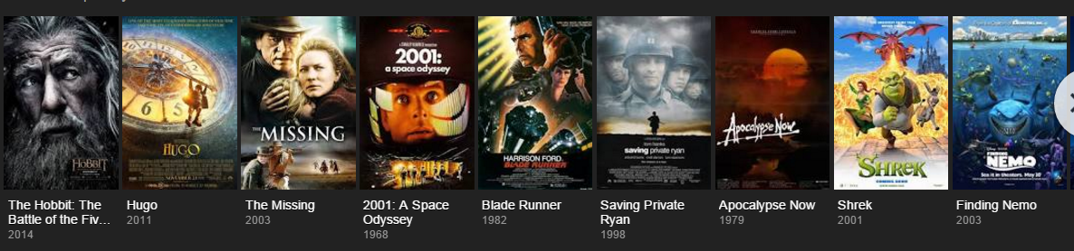
Quest stories are some of the most popular of literature and are very fitting for this A10 Unit on Challenges. Before watching one, though, you first have to understand the characteristics of a quest story.

Before Viewing
Consider your own definition of what a “Quest” is. Write as clear a definition below as you can, being sure to include examples to support your definition. Consider what elements of a Quest story make it unique from any other type of story.
Now go to the following website (see QR Code) and read through the given characteristics and requirements for a true Quest Story. Consider if there would be any change in your plot line if you had to chart this story. Also be sure to take note of the character types / groupings. Use the space below to add notes you feel are important.

Now, as you watch, track the elements of a Quest you find in the movie The Four Feathers. You can fill in the chart as you watch or you can jot notes down during and fill the chart in after watching.
Be sure the responses you fill in are your own. Challenge yourself to complete it without help from others.

During Viewing
Notes during watching

Climax

Falling Action
Rising Action x 4

Resolution
Problem

Setting: (T/P)
Protagonist:
Antagonist:
Conflict Source:

