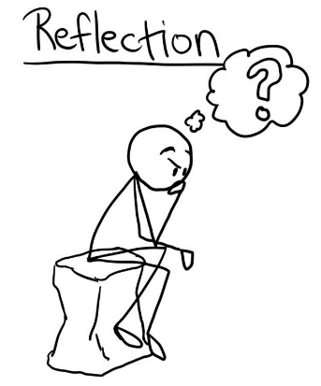
Nearing the end of your final High School ELA course, it would be nice for you to be able to reflect on the type or quality of work you were completing earlier in your high school years compared to now. You previously contributed work to a personal blog, so you have a collection of previous work that you can review.
Name: _______________________
I’d like you to take some time to look back through your ELA work on your blog and reflect on whether you feel you’ve grown in:
- Skill in ELA
- Confidence in writing
- Confidence in creative activities
- Expressing yourself through a variety of ways
- As you look through your blog work, write out a list of at least 5 characteristics you can identify of your previous work:
- What are your thoughts of your previous work now that you’ve read through some of it?
- After reviewing your first big formal written assignment in ELA, what stands out to you about your work from several years ago? Can you give a specific example to support your response?
- Overall, do you think you’ve grown in skill and confidence in ELA or remained at a similar level? Explain with an example or fully described response.
- Understanding now that Metacognition if “thinking about your learning” to understand your skills and use strategies to enhance success of a goal, rate your confidence below of:
  - Your ability of being aware of your learning on a scale of 1 (low) to 10 (high) and explain your reasoning.
  - The influence of your metacognition in helping improve your success on a scale of 1 (low) to 10 (high) and explain your reasoning.
- Choose any four of the following and develop a response below. Try to give specific examples with your answers.
Describe a time when you:
  - Felt deeply involved / interested / invested in an activity or assignment.
  - Expressed ideas or feelings you were surprised by or had never expressed before
  - Benefited from a shared experience in working with a group or partner and learned something new from them
  - Experimented with how you expressed your ideas
  - Revised your own ideas in light of something discussed in class
  - Felt an activity or work really challenged or forced you to decide on your position of a concept
  - Took risks in an activity or assignment
  - Learned something new about yourself as a learner
  - Used a strategy or method of becoming more successful in a task or assignment
  - Linked something discussed in ELA to another course subject or discussion outside of ELA class
  - Used learning strategies you picked up from ELA in another circumstance outside ELA

